Sirjana Poudel

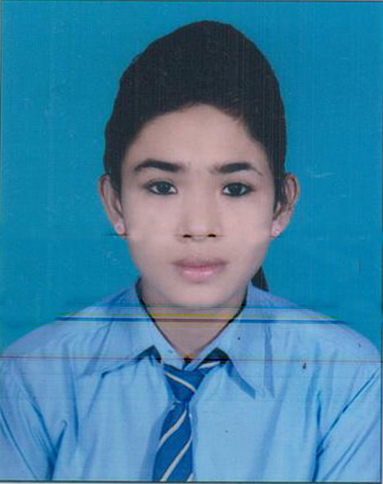
Sirjana Poudel Is a student of class 8 studying in Surje Devi secondary school. She is very obedient and hard working student. Due to her hardworkship and good learning skill, she was able to score 93% in her 7th grade.Her both academic and extra activities are praiseable.
Sirjana's father is a respectful police officer in police department. She gets motivated by her father so that she wills to be a army officer.Being a skillful talented student she and her father dreams of fulfilling Srijian's dream but unfortunately her other family members doesnt allow her to continue her studies.Her family wants her to leave her education and get married with a person who is 3 times older than her. Being from a social evil society its diffcult for srijana to continue her student as she gets forced to marry daily by her family memebers she lives with her friends at their home to aviod her marriage situation.
Srijana's father can’t make a suitable time to stay at home for hours and make his daughter more build up for studies. When her father gets to work and can’t make time to come home for two three days at that time her family members cut of all her suppliers which she uses in her eduction. Having a tough time she still wishes to study and fullfil her and her fathers dream.
Education is a very important factor for living so that we should never leave hope and continue our dreams.

